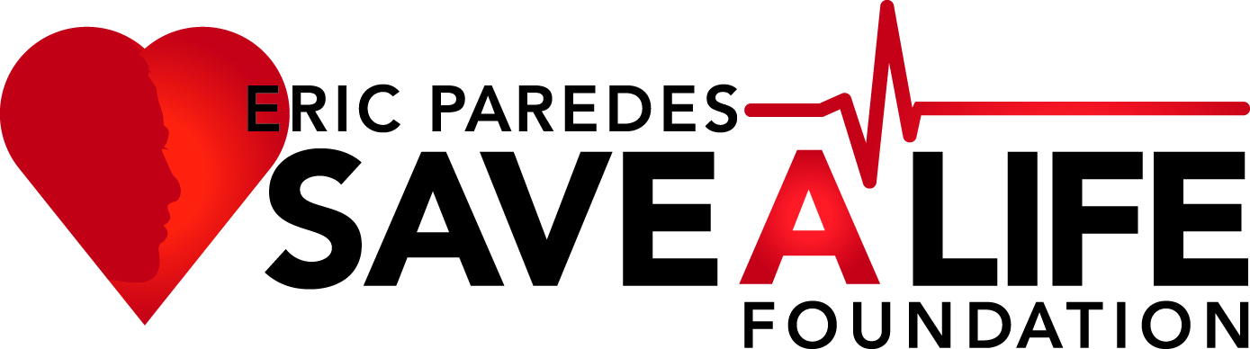

**Keep Their Heart in the Game**

A Sudden Cardiac Arrest Information Sheet for Athletes and Parents/Guardians

**What is sudden cardiac arrest?**

Sudden cardiac arrest (SCA) is when the heart stops beating, suddenly and unexpectedly. When this happens blood stops flowing to the brain and other vital organs. SCA is NOT a heart attack. A heart attack is caused by a blockage that stops the flow of blood to the heart. SCA is a malfunction in the heart’s electrical system, causing the victim to collapse. The malfunction is caused by a congenital or genetic defect in the heart’s structure.

**How common is sudden cardiac arrest in the United States?**

As the leading cause of death in the U.S., there are more than 350,000 cardiac arrests outside hospitals annually, with nine out of 10 resulting in death. Thousands of sudden cardiac arrests occur among youth each year, as it is the #1 killer of student athletes during exercise and the leading cause of death on school campuses.

**Who is at risk for sudden cardiac arrest?**

SCA is more likely to occur during exercise or physical activity, so student-athletes are at greater risk. While a heart condition may have no warning signs, studies show that many young people do have symptoms but neglect to tell an adult. This may be because they are embarrassed, they do not want to jeopardize their playing time, they mistakenly think they’re out of shape and need to train harder, or they simply ignore the symptoms, assuming they will “just go away.” Additionally, some health history factors increase the risk of SCA.

**What should you do if your student-athlete is experiencing any of these symptoms?**

We need to let student-athletes know that if they experience any SCA-related symptoms it is crucial to alert an adult and get follow-up care as soon as possible with a primary care physician. Likewise, parents can be proactive in reviewing the symptoms directly with their student athlete versus just assuming they’re OK if they haven’t said otherwise. If the athlete has any of the SCA risk factors based on family history, these should also be discussed with a doctor to determine if further testing is needed. Wait for your doctor’s feedback before returning to play, and alert your coach, trainer and school nurse about any diagnosed conditions.

**Warning Signs That SCA May Occur**

• Fainting or seizure, especially during or right after exercise

• Fainting repeatedly or with excitement or startle

(Fainting is the #1 sign of a potential heart condition)

• Excessive shortness of breath during exercise

• Racing or fluttering heart palpitations or irregular heartbeat

• Repeated dizziness or lightheadedness

• Chest pain or discomfort with exercise

• Excessive, unexpected fatigue during or after exercise

**Family History Factors That Increase the Risk of SCA**

• Family history of known heart abnormalities or sudden death before age 50

• Specific family history of Long QT Syndrome, Brugada Syndrome, Hypertrophic Cardiomyopathy, or Arrhythmogenic Right Ventricular Dysplasia (ARVD)

• Family members with unexplained fainting, seizures, drowning or near drowning or car accidents

• Known structural heart abnormality, repaired or unrepaired

• Use of drugs, such as cocaine, inhalants, “recreational” drugs, excessive energy drinks, diet pills or performance-enhancing supplements

**What can you do to protect young hearts?**

1. Talk with your son or daughter about potential warning signs noted above, and check your family tree for the above risk factors. Discuss any warning signs and risk factors with your primary care physician immediately.
2. Know the Cardiac Chain of Survival.
3. Help make AEDs available at your school or sports team.

**What is the Cardiac Chain of Survival?**

On average, it takes EMS teams up to 12 minutes to arrive to a cardiac emergency. Every minute delayed in attending to a sudden cardiac arrest victim decreases the chance of survival by 10%. Everyone should be prepared to take action in the first minutes of collapse. These are the five steps:

1. Recognition of Sudden Cardiac Arrest

Collapsed and unresponsive. They are not breathing, even if you hear gasping, gurgling, snorting, moaning or labored breathing noises, or see seizure-like activity. Do not lose precious minutes trying to “wake them up” – act immediately!

1. Call 9-1-1
2. Perform Hands-Only CPR

Begin cardiopulmonary resuscitation (CPR) immediately. Hands-only CPR involves hard and fast

and continual two-inch chest compressions in the center of the chest—about 100 per minute. CPR can be a bridge to life until the AED arrives.

1. Retrieve an AED

Know the location of the school’s automated external defibrillator (AED) and use it as soon as possible. Mobile AED units have step-by-step instructions for a bystander to use in an emergency situation – you do not need to be a medical professional to use an AED.

1. Direct EMS to the Scene

Send a bystander to show Emergency Medical Services (EMS) where the victim is.

**What is an AED?**

An automated external defibrillator (AED) is **the only way to save a sudden cardiac arrest victim**. An AED is a portable, user-friendly device that automatically diagnoses potentially life-threatening heart rhythms and delivers an electric shock to restore normal rhythm. Anyone can operate an AED, regardless of training. Simple audio direction instructs the rescuer when to press a button to deliver the shock, while other AEDs provide an automatic shock if a fatal heart

rhythm is detected. A rescuer cannot accidently hurt a victim with an AED—quick action can only help. AEDs are designed to only shock victims whose hearts need to be restored to a healthy rhythm. Always know the location of an AED where your youth is playing.

with your school for locations of on-campus AEDs.

**What are we doing to protect youth from sudden cardiac arrest?**

The Eric Paredes Sudden Cardiac Arrest Prevention Act was passed in 2016. It mandates that parents/guardians and student athletes participating in school sponsored athletic activities in K-12 public, private and charter schools review and sign an SCA information sheet, and that coaches take SCA Awareness training and repeat every two years. The Act also empowers coaches to remove from practice or play a student athlete who faints, and to discuss other warning signs with parents/guardians. Additionally, a student exhibiting any other warning signs of sudden cardiac arrest (unexplained shortness of breath, chest pains, dizziness, racing heart, extreme fatigue) during athletic activities may be removed from participation by the athletic director or authorized person if it’s reasonably believed that it’s cardiac related.

The student athlete must then be evaluated and cleared by a doctor (physician/surgeon, nurse practitioner or physician assistant) before returning to play.

*INSERT YOUR PROGRAM PROTOCOL IF YOUR PROGRAM IS NOT PART OF A K-12 SCHOOL*

**For more information on Sudden Cardiac Arrest in youth and the Eric Paredes Sudden Cardiac Arrest Prevention Act, visit the Eric Paredes Save A Life Foundation at** [**epsavealife.org**](https://epsavealife.org/)**, the California Department of Education at** [**cde.ca.gov**](https://www.cde.ca.gov/ls/he/hn/)**, the California Interscholastic Federation (CIF)** [**cifstate.org**](http://cifstate.org/sports-medicine/sca/index) **or your regional CIF section website.**